Machine learning Lab Observation
ITA0614
Experiment 2
For a given set of training data examples stored in a .CSV file, implement and demonstrate the Candidate-Elimination algorithm in python to output a description of the set of all hypotheses consistent with the training examples.
Name : G.B.Hari Haran
Reg.No : 192412390
Problem 1 : EnjoySport
Aim
To implement the Candidate-Elimination algorithm on the EnjoySport training data stored in a .CSV file and output the S and G boundary sets of the version space.
Algorithm
- Initialise G to the maximally general hypothesis, <?, ?, ..., ?>, and S to the maximally specific hypothesis, <0, 0, ..., 0>.
- For each training example d:
If d is a positive example: remove from G every hypothesis inconsistent with d. For each s in S that is inconsistent with d, remove s and add all minimal generalisations h of s such that h is consistent with d and some member of G is more general than h. Remove from S any hypothesis that is more general than another hypothesis in S.
If d is a negative example: remove from S every hypothesis inconsistent with d. For each g in G that is inconsistent with d, remove g and add all minimal specialisations h of g such that h is consistent with d and some member of S is more specific than h. Remove from G any hypothesis that is less general than another hypothesis in G.
- Output the boundary sets S and G (the version space lies between them).
Program:
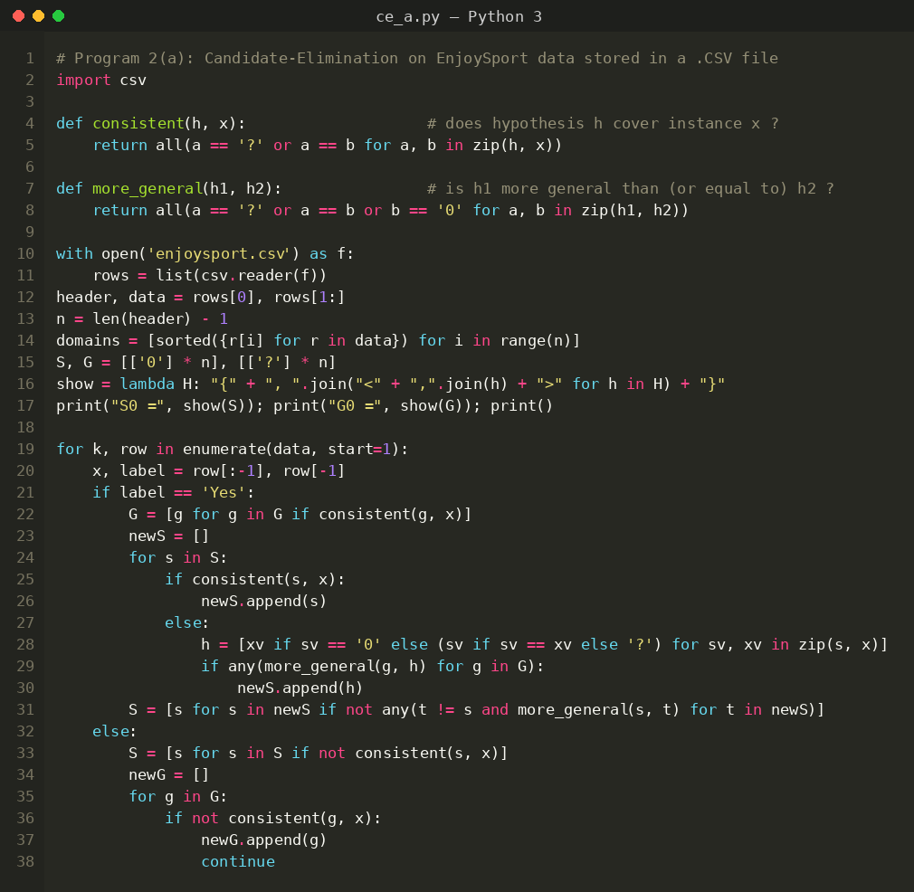
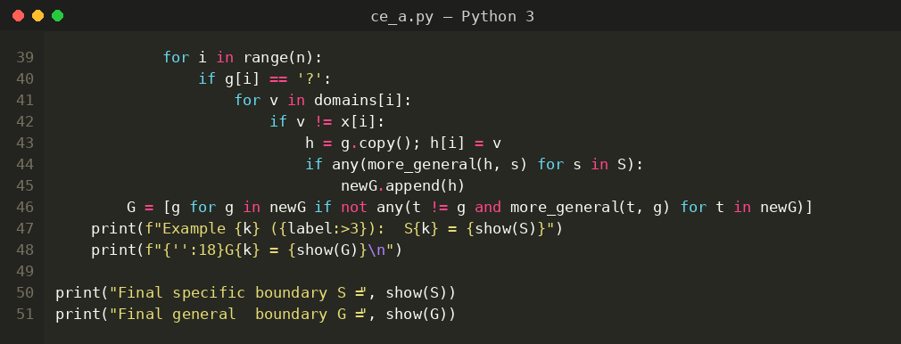
Input
EnjoySport data set (enjoysport.csv): 4 examples, 6 attributes (Sky, AirTemp, Humidity, Wind, Water, Forecast) and the target concept EnjoySport (Yes / No). The attribute domains are taken automatically from the file.
Sky | AirTemp | Humidity | Wind | Water | Forecast | EnjoySport
Sunny | Warm | Normal | Strong | Warm | Same | Yes
Sunny | Warm | High | Strong | Warm | Same | Yes
Rainy | Cold | High | Strong | Warm | Change | No
Sunny | Warm | High | Strong | Cool | Change | Yes
Output
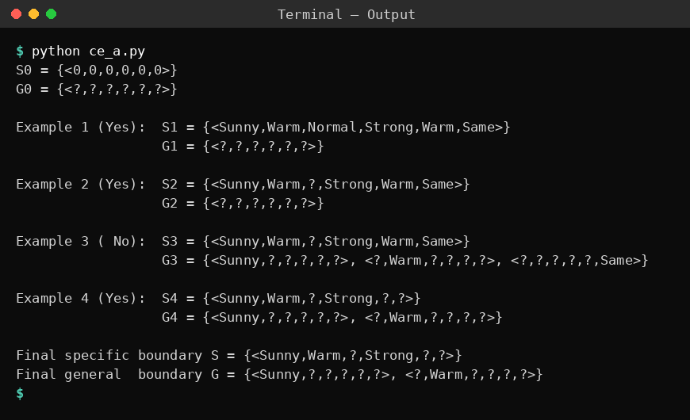
Result
The version space for the EnjoySport data is bounded by S = {<Sunny, Warm, ?, Strong, ?, ?>} and G = {<Sunny, ?, ?, ?, ?, ?>, <?, Warm, ?, ?, ?, ?>}. G contains <?, ?, ?, ?, ?, Same> after the third example, but it is removed after the fourth example because it is inconsistent with the last positive example.
Problem 2: Fruit classification
Aim
To implement the Candidate-Elimination algorithm using the pandas library on a fruit data set and to find the boundary sets S and G.
Algorithm
- Initialise G to the maximally general hypothesis, <?, ?, ..., ?>, and S to the maximally specific hypothesis, <0, 0, ..., 0>.
- For each training example d:
If d is a positive example: remove from G every hypothesis inconsistent with d. For each s in S that is inconsistent with d, remove s and add all minimal generalisations h of s such that h is consistent with d and some member of G is more general than h. Remove from S any hypothesis that is more general than another hypothesis in S.
If d is a negative example: remove from S every hypothesis inconsistent with d. For each g in G that is inconsistent with d, remove g and add all minimal specialisations h of g such that h is consistent with d and some member of S is more specific than h. Remove from G any hypothesis that is less general than another hypothesis in G.
- Output the boundary sets S and G (the version space lies between them).
Program:
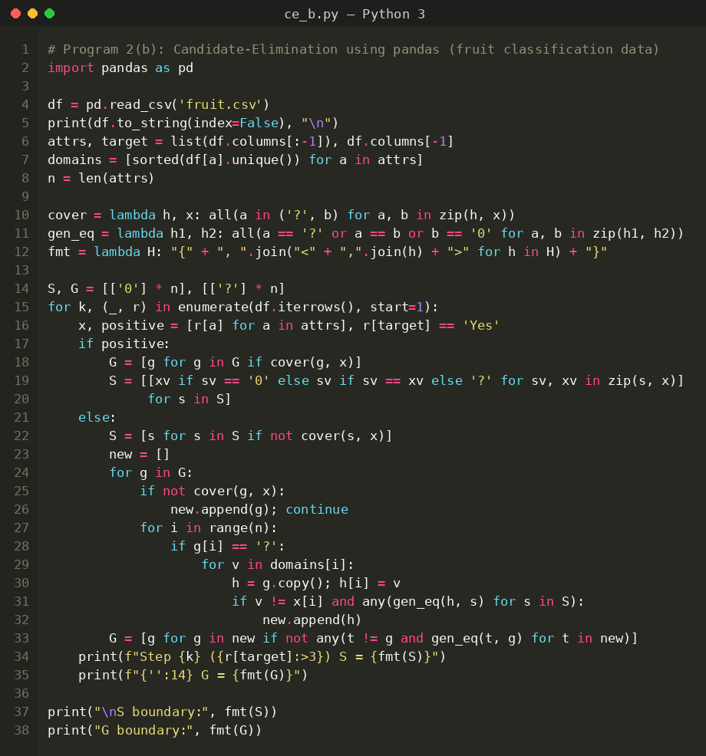
Input
Fruit data set (fruit.csv): 5 examples, 4 attributes (Color, Shape, Size, Taste) and the target concept IsApple (Yes / No), loaded as a pandas DataFrame.
Color | Shape | Size | Taste | IsApple
Red | Round | Medium | Sweet | Yes
Red | Round | Small | Sweet | Yes
Yellow | Long | Medium | Sweet | No
Green | Round | Medium | Sour | No
Red | Round | Large | Sweet | Yes
Output
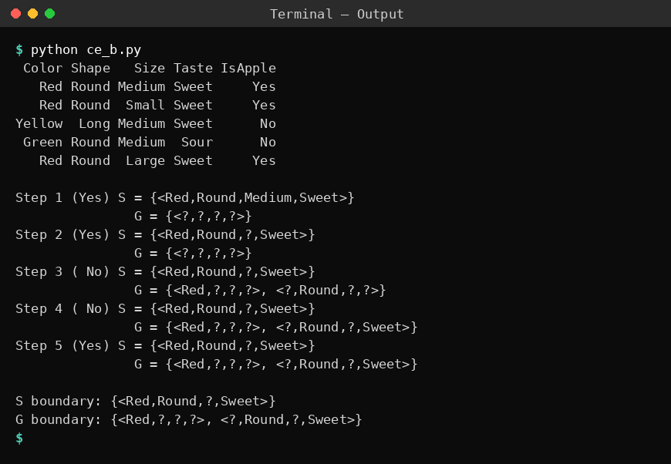
Result
After processing all five examples the boundaries are S = {<Red, Round, ?, Sweet>} and G = {<Red, ?, ?, ?>, <?, Round, ?, Sweet>}. Every hypothesis between these two boundaries is consistent with the fruit training data.
Problem 3: Loan approval
Aim
To implement the Candidate-Elimination algorithm in the commonly used form in which S is initialised with the first positive training example, using loan approval data from a .CSV file.
Algorithm
- Initialise G to the maximally general hypothesis, <?, ?, ..., ?>, and S to the maximally specific hypothesis, <0, 0, ..., 0>.
- For each training example d:
If d is a positive example: remove from G every hypothesis inconsistent with d. For each s in S that is inconsistent with d, remove s and add all minimal generalisations h of s such that h is consistent with d and some member of G is more general than h. Remove from S any hypothesis that is more general than another hypothesis in S.
If d is a negative example: remove from S every hypothesis inconsistent with d. For each g in G that is inconsistent with d, remove g and add all minimal specialisations h of g such that h is consistent with d and some member of S is more specific than h. Remove from G any hypothesis that is less general than another hypothesis in G.
- Output the boundary sets S and G (the version space lies between them).
Program:
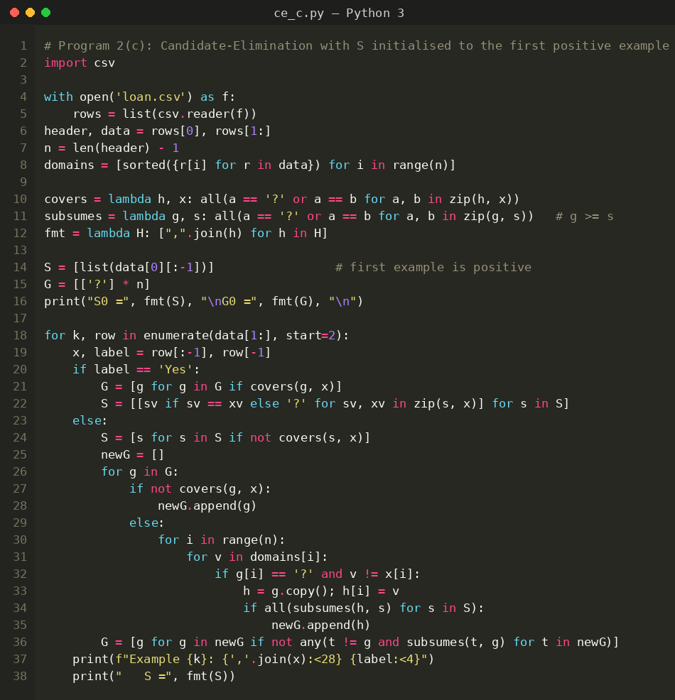
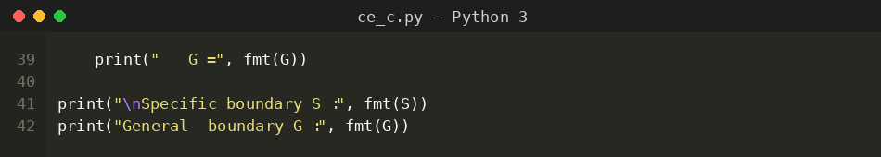
Input
Loan data set (loan.csv): 5 examples, 4 attributes (Income, Employment, Credit, Age) and the target concept Approved (Yes / No). The first row of data is a positive example.
Income | Employment | Credit | Age | Approved
High | Salaried | Good | Adult | Yes
Medium | Salaried | Good | Adult | Yes
Low | Salaried | Bad | Adult | No
High | Self | Good | Senior | Yes
Low | Self | Bad | Senior | No
Output
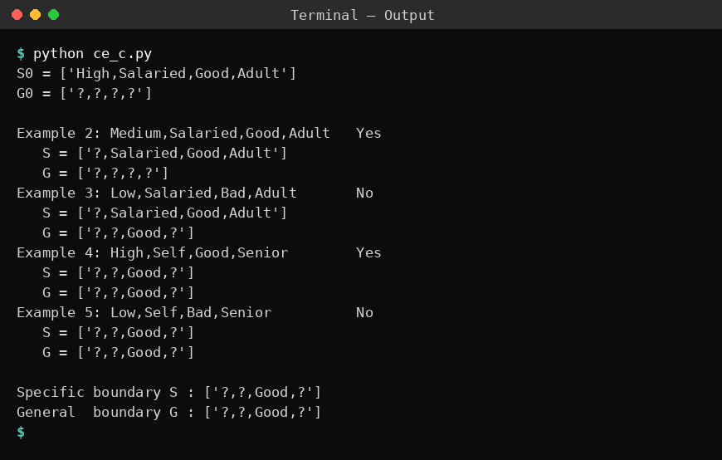
Result
Both boundaries converge to the single hypothesis S = G = {<?, ?, Good, ?>}. The version space contains only this hypothesis, so the loan is approved if and only if the credit history is Good.
Problem 4: Mushroom
Aim
To implement Candidate-Elimination as a Python class and to enumerate every hypothesis of the version space that lies between the S and G boundaries.
Algorithm
- Initialise G to the maximally general hypothesis, <?, ?, ..., ?>, and S to the maximally specific hypothesis, <0, 0, ..., 0>.
- For each training example d:
If d is a positive example: remove from G every hypothesis inconsistent with d. For each s in S that is inconsistent with d, remove s and add all minimal generalisations h of s such that h is consistent with d and some member of G is more general than h. Remove from S any hypothesis that is more general than another hypothesis in S.
If d is a negative example: remove from S every hypothesis inconsistent with d. For each g in G that is inconsistent with d, remove g and add all minimal specialisations h of g such that h is consistent with d and some member of S is more specific than h. Remove from G any hypothesis that is less general than another hypothesis in G.
- Output the boundary sets S and G (the version space lies between them).
Program:
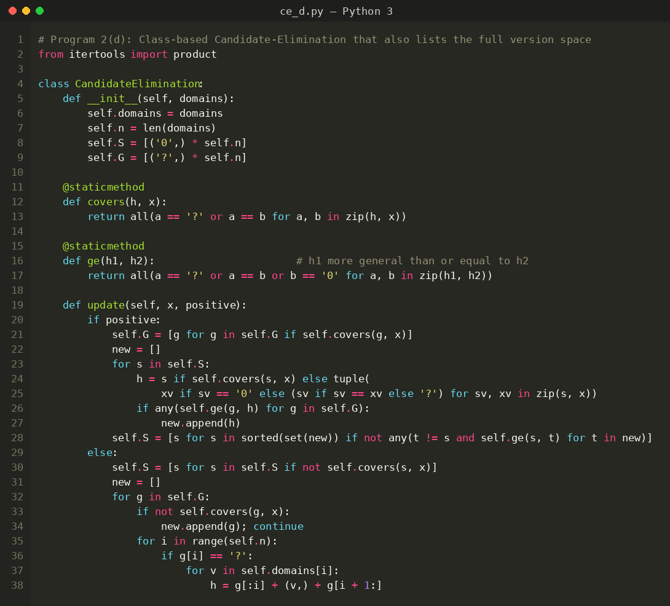
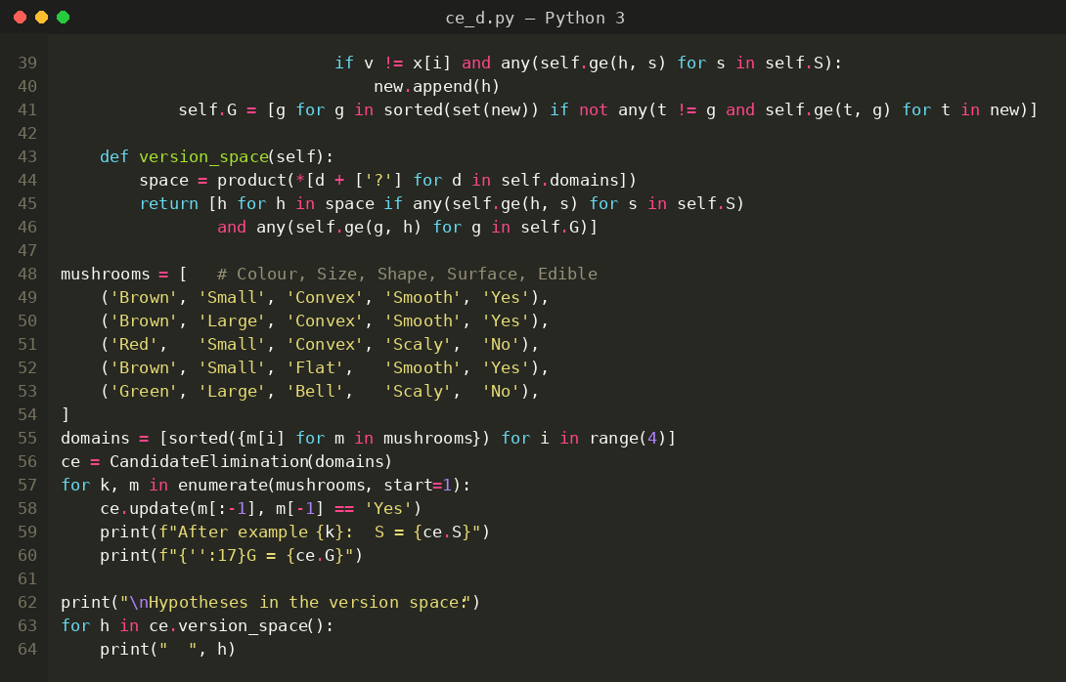
Input
Mushroom data set: 5 examples, 4 attributes (Colour, Size, Shape, Surface) and the target concept Edible (Yes / No). The data is stored in the program as tuples.
Colour | Size | Shape | Surface | Edible
Brown | Small | Convex | Smooth | Yes
Brown | Large | Convex | Smooth | Yes
Red | Small | Convex | Scaly | No
Brown | Small | Flat | Smooth | Yes
Green | Large | Bell | Scaly | No
Output
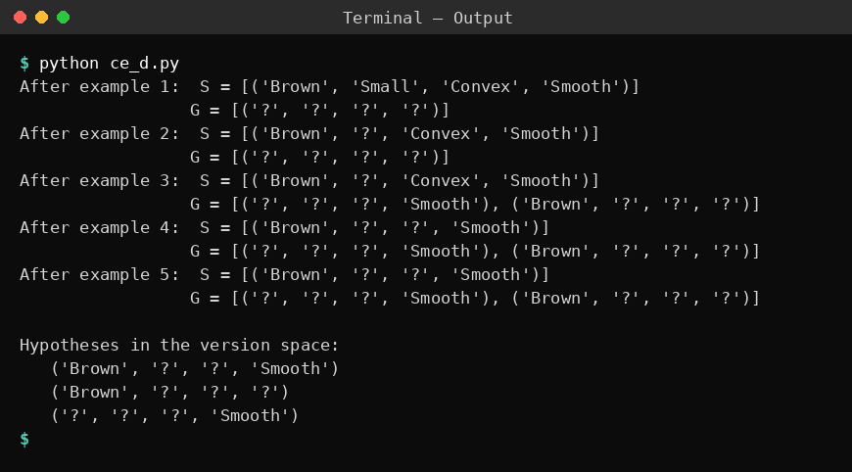
Result
The final boundaries are S = {<Brown, ?, ?, Smooth>} and G = {<?, ?, ?, Smooth>, <Brown, ?, ?, ?>}. The version space contains exactly three hypotheses: <Brown, ?, ?, Smooth>, <Brown, ?, ?, ?> and <?, ?, ?, Smooth>.
Problem 5: Student placement
Aim
To apply the Candidate-Elimination algorithm to student placement data and to use the S and G boundaries to classify new samples.
Algorithm
- Initialise G to the maximally general hypothesis, <?, ?, ..., ?>, and S to the maximally specific hypothesis, <0, 0, ..., 0>.
- For each training example d:
If d is a positive example: remove from G every hypothesis inconsistent with d. For each s in S that is inconsistent with d, remove s and add all minimal generalisations h of s such that h is consistent with d and some member of G is more general than h. Remove from S any hypothesis that is more general than another hypothesis in S.
If d is a negative example: remove from S every hypothesis inconsistent with d. For each g in G that is inconsistent with d, remove g and add all minimal specialisations h of g such that h is consistent with d and some member of S is more specific than h. Remove from G any hypothesis that is less general than another hypothesis in G.
- Output the boundary sets S and G (the version space lies between them).
Program:
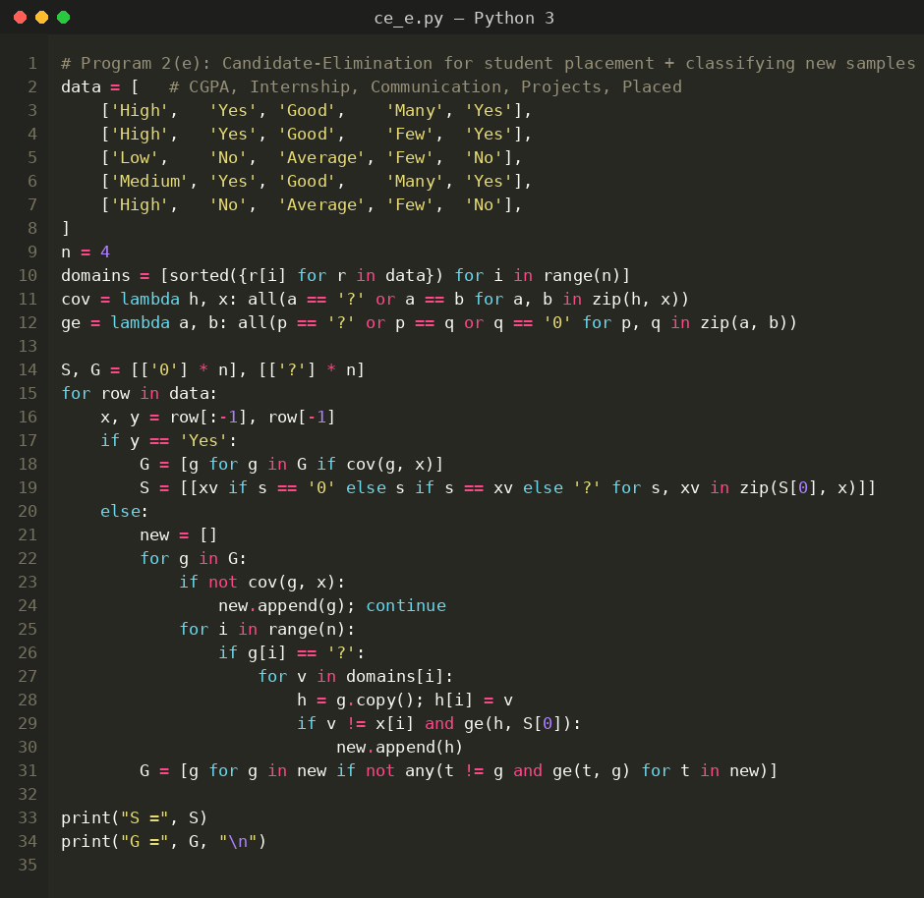
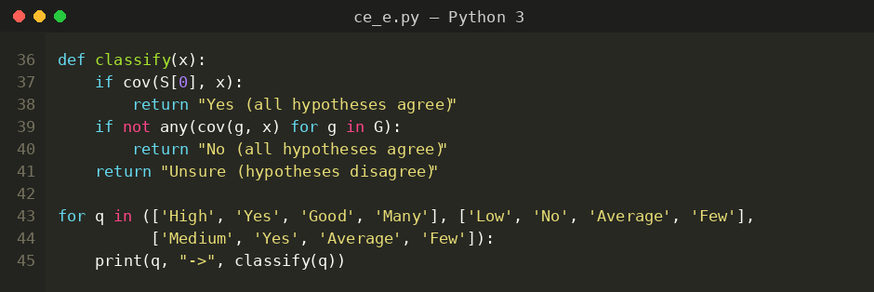
Input
Student Placement data set: 5 examples, 4 attributes (CGPA, Internship, Communication, Projects) and the target concept Placed (Yes / No).
CGPA | Internship | Communication | Projects | Placed
High | Yes | Good | Many | Yes
High | Yes | Good | Few | Yes
Low | No | Average | Few | No
Medium | Yes | Good | Many | Yes
High | No | Average | Few | No
Output
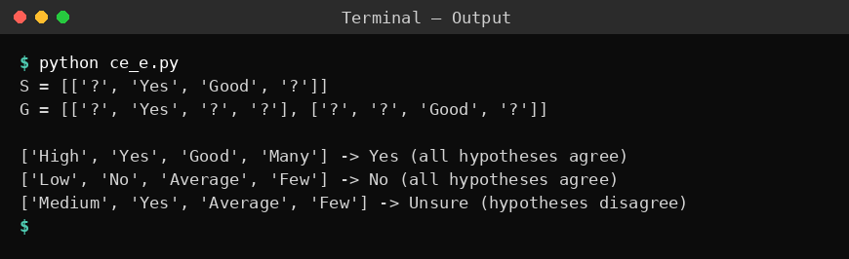
Result
The boundaries obtained are S = {<?, Yes, Good, ?>} and G = {<?, Yes, ?, ?>, <?, ?, Good, ?>}. Using them, (High, Yes, Good, Many) is classified Yes, (Low, No, Average, Few) is classified No and (Medium, Yes, Average, Few) cannot be classified with certainty because the hypotheses of the version space disagree.

